Flatter Than Earth - LD Test - Salim Ali

1) Analyzing Platformers

Name of Game: INSIDE

Walkthrough Video Reference: <https://youtu.be/6khugF2iWBY>

INSIDE was released in 2016 and was widely acclaimed for its creative puzzles and captivating narrative. The world that INSIDE created was open to interpretation and the story it told drew in players to ask meaningful questions. It seemed like a simple game on cover, however its familiar mechanics were made use of in extremely smart ways to create an engaging puzzle platformer.

One of the things I liked most about INSIDE was how the game built upon its simple yet interesting mechanics to scale up so beautifully well throughout the length of the game. The first one that comes to mind, is the characters mind control ability (no pun intended). The first time the player encounters the hanging helmet, the way it is lit up and positioned with respect to the bleak background immediately pings it as an object of interest and directs attention towards it. Upon coming into contact with the helmet, the controllable characters (hereby referred to as Followers) stand up and are positioned such in the camera that they are immediately visible. Regardless of whether the player realizes what this means, or whether they feel that the Followers will be hostile and attack them, their natural instinct would be to move/run, and in doing so they would figure out the new feature they just picked up on their own. This I felt was a great way to tutorialize the mechanic, as well as a really cool way to expand on the players ability to move which is integral to almost any platformer.

Following on, the game develops on this core mechanic very creatively, using it in engaging and thought provoking ways in future puzzles such as by controlling one Follower to control another Follower to open up the path ahead. Restricting player movement in these earlier cases works well to allow the player to focus on understanding the fundamentals of the ability so that it is as natural to them as the back of their hand. Eventually players gain the ability to permanently control nearby Followers without being stuck in one place, which opens up the room for larger scaled puzzles that the player can now make better sense of after getting the chance to become familiar with the core mechanic. Eventually, when the player merges with the blob, this mechanic reaches the ultimate player fantasy of ascending to embody the hive mind, controlling the masses towards their goal.

I also really appreciate how well the game piggy backs on common logic, physics, and worldly know how that players would be familiar with. This is done exceptionally well with pseudo-combat encounters that stay true to the games simple controls and focus on puzzles. Jumping over the pig to get it to charge into walls, holding wolves at bay with a torch, these encounters and more were smoothly laid out, and built into the larger story nicely instead of breaking the players immersion. The utilization of these sensibilities combined with the games intuitive mechanics lead to some really creative dynamics that felt great to execute such as using the submarines charge ability to break the waters surface and jump through doors, or reacting to shadows created by moving lights on stationary objects to stay out of sight. Figuring out the solution to these puzzles felt both natural and rewarding.

The levels in the game were very well paced. They were divided into nicely sized sections where the player would have to use similar logic to beat progressively challenging beats that lasted just the right amount of time before they were switched up. The puzzles also felt fresh and approachable, having players both think creatively and act with finesse around the varying constraints. The variety in the types of puzzles was also remarkable, with frequent wow moments and cool sights.

The game also made extremely good use of colour language and lighting/silhouettes to guide and inform the player. The game used its overall grey colortone not just to build a surreal atmosphere, but also as a great tool towards uplifting the gameplay. Having the mind control helmets glow yellow as well as having yellow cables lead to secrets was a fantastic nod to the story, as well as a consistent element players could feel smart about just by keeping an eye out. The animations of the game also flowed seamlessly, without breaking the stride of movement. Interacting with switches or jumping off off platforms and rolling back into movement felt quick and responsive adding to the immersion.

With the puzzles and creative use of mechanics on point, the story INSIDE told was also amazingly crafted. Even though a lot of the subject matter was abstract and open to interpretation, the threads spun seemed well connected and sparked curiosity. Gameplay also tied into the narrative really well, as it seamlessly subverted player expectations time and time again to keep the mind actively asking questions. The game made some very interesting commentaries on life, often through the solutions to puzzles, which led to mind blowing revelations and eureka moments.

There were a couple of situations where objects seemed to move differently than expected or how they had behaved previously which I felt added a few inconsistencies. That coupled with the games inherently abstract narrative led to some confusing moments where the answer was not completely clear. However these moments were very few and far between and were often not as mechanically testing and thus allowed the player enough time to ponder and come to terms with their surroundings.

All in all INSIDE was a great game to go through with a lot of smart design decisions and facets to learn from. With clever use of its minimal tools it made itself both inviting and appealing to a large audience, and managed to captivate them with a story that felt real as well as open for players to add the colours of their own imaginations to it.

2) Deconstructing Level

Name of Game: Luigis Mansion 3

Name of Level: River Bank - DLC Pack 1 Party Mode

Gameplay Video Link: <https://youtu.be/6Lunc_N2FX4?t=392>

**Brainstorming:**

The level that eventually became River Bank started off with the idea of having a Party Mode where instead of the players moving around the level per-se, the level came to the player. The core rule was that hazards and/or rewards would spawn at the north end, and move south towards the player. The zaniness of this Japanese Gameshow theme fit LM3s charm and doll-house camera well and felt like something both eastern and western audiences would be able to relate to.

**Approval:**

The focus was to combine the core rule of the party mode mentioned above with core LM3 mechanics like Burst, Vacuum etc to create an engaging loop. I came up with a bunch of various designs and interpretations around these concepts with different combinations of hazards, and ways for teams to build towards victory. Some of these got players platforming using Burst to jump over hurdles, and through gaps in order to avoid falling off the edge of a giant conveyor belt. Others incorporated puzzle elements, having players use the vacuum to suction and shoot paint cans on matching colour sections of incoming walls to create holes to pass through. One design had players in a mad dash to collect as many incoming coins as possible. I iterated over these designs with my team, and passed them along to our publisher (Nintendo) to get the necessary approvals. The two key takeaways we took out of their feedback was that movement needed to be the focus, and that the simpler the other elements were the better. They suggested using Ducky controls, where the players would be seated in a water ducky vehicle and would need to use their vacuum to move around. This marriage hit a sweet spot and paved the way to begin the prototype.

**Prototyping:**

The brainstorming and approval phases, and the documentation and diagrams created for them gave me a good idea on where I wanted to start with how I wanted the arena to look and feel. I set out whiteboxing the arena in engine laying out the shapes and structures that would define player movement. I added the water plane and the player characters as early as possible so that I could start getting a feel for how the play space felt, and continued to iterate over the level geo as well as the camera viewport. Once I had a rough layout in place, I began scripting basic gameplay elements such as obstacles, hazards, and coins to see what worked and what didnt. I also added a water current effect to move the water southwards, ending in a waterfall drop that players had to avoid falling over (A). Each time I added a new element I made sure to have other people play around with them to collect their feedback in order to hone in on the fun. We realized pretty early on that interactions where players bumped around into each other like ping ponging bumper cars led to the most comical outcomes and fun moments. These observations really helped solidify the gameflow and core loop as they provided me with a strong pillar to centre my decisions around. To accentuate these moments, it was important to bring all the players towards the centre of the arena where they were most probable to bounce into each other. For this I had players entering the arena at the half way line, and every time they died their coins would eject towards the middle of the pool creating a contested zone where players would be encouraged to come duke it out. Players edging too close to the North (B) would be pulled in slightly and then pushed back out towards the centre of the pool to encourage aggressive plays. The safe zone on the left and right side (C) allowed for a moment of reprieve with bounce pads (D) to quickly reenter the fray, at the expense of creating an easy opening for players in the centre to come and pop safety seekers on the spikes (E). At this stage I also created a system for storing combinations and patterns of elements and the logic for spawning them allowing me to control their layouts, speeds, and frequencies to ensure that they felt balanced, fun, and consistent with the design pillars.

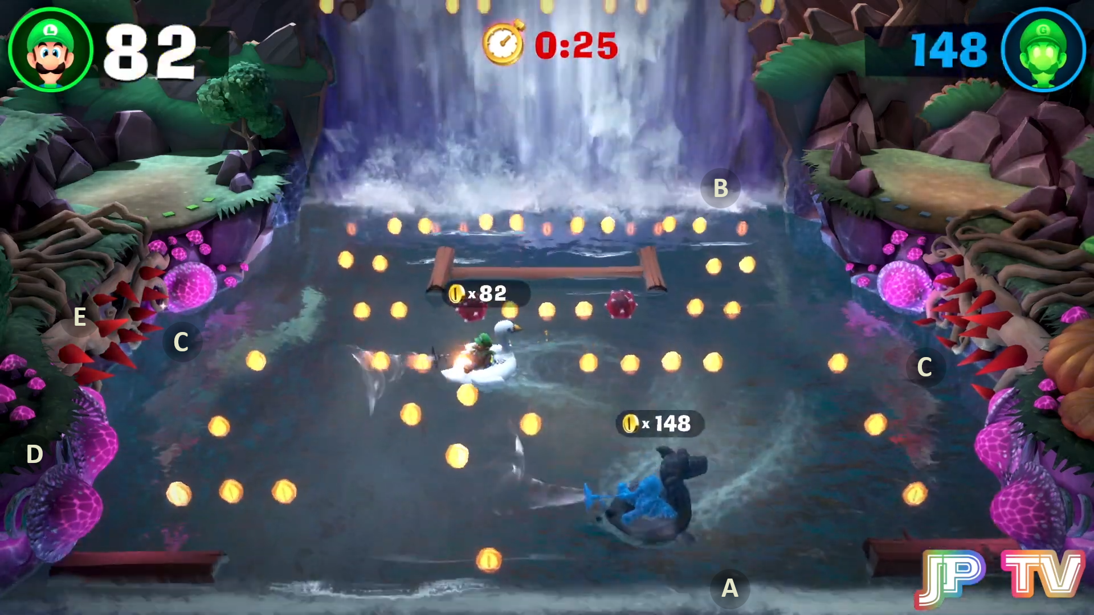

**Production and Polish:**

As the iterations on the prototype progressed, it eventually reached a place where our publishers were happy with it to start production. Designs started getting locked in place and my main tasks transitioned to communicating them to the rest of the team as they created assets and refined the code. It was an amazing experience and feeling to see the work my fellow teammates put into bringing the game mode to life. Balancing and tuning the level was also a key focus during this time as I polished the flow and patterns of elements. Additionally, there was a lot of playtesting, not only to see if the gameplay held up but also to find and squeeze out any bugs.

**Conclusion:**

All in all I had a blast designing this level and solving the unique challenges it posed. Just recalling my journey through it as I wrote this piece brought fond memories and smiles.

3) Level Design Project - INSIDE

**Level Set Up:**

For this part of the test I took the research I had done for Question 1 a step further and decided to create a level for INSIDE. The level I have designed is to take place just after the Sonar puzzle section (timestamp 1:04:00 in Question 1 video). It ends as the player enters the elevator that is destroyed later on in the game, plummeting them into water.

With my level I wished to evoke feelings of being on the run with the drive and goal of reaching a purpose, no matter the cost. Geographically, the player (represented by the Brown Capsule) would at this point be journeying deeper into the facility to get into contact with the Blob. The earlier part of the level has the player attempting dexterous feats and manoeuvres as they avoid a gruesome fate by large deadly machines that have little respect for life. These machines serve the facility in getting rid of bodies that are of no use to the organization in control. The players get a glimpse of the extent to which others can fall to achieve their goals, discarding life without a care. The latter part of the level puts the player in those same shoes getting them to ask the questions they were asking the system, to themselves. To progress further they must now use these same contraptions to pave open the way ahead, using the bodies of others (represented by the Black Capsules) as fodder.

**Control Scheme:**

Controls to go through the level can be looked up in the table below. The Gamepad controls reflect the default mappings used by the game. The keyboard controls I have slightly modified, since the game allows the player to customize them as they see fit and so I took the liberty to use the bindings I felt more comfortable with. I have also added a few developer shortcuts/controls to help with testing the level, as well as to make going through my submission smoother.

|  |  |  |
| --- | --- | --- |
| **Control** | **Keyboard** | **Gamepad (X-Box)** |
| Movement | WASD and Arrow Keys | Left Stick |
| Jump | Space | A |
| Interact | E | X |
| Quit | Q | Start |
| Last Checkpoint | R | Back |
| Hop to Checkpoint | 0, 1, 2, 3 | - |
| Hints / Controls Toggle | H | Left Bumper |

**Packages Used:**

Probuilder: White boxing and level design

TextMeshPro: Placeholder text and notifications

Cinemachine: Camera follow and adjustments

**References and Links:**

1. Brackeys YouTube Tutorial on setting up GitHub:

Link: <https://www.youtube.com/watch?v=qpXxcvS-g3g&ab_channel=Brackeys>

2. Maka91Productions Walkthrough of INSIDE:

Link: <https://youtu.be/6khugF2iWBY>

3. BMo's YouTube tutorial on Unity Events best practices

Link: <https://www.youtube.com/watch?v=cLzG1HDcM4s&ab_channel=BMo>

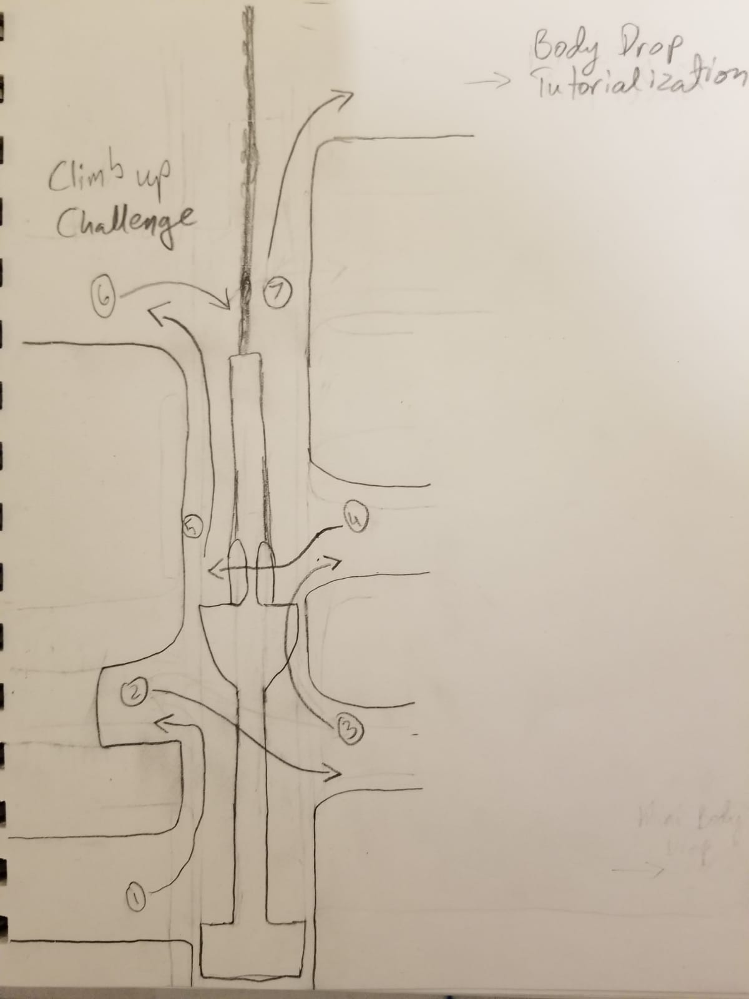**Paper Designs:**

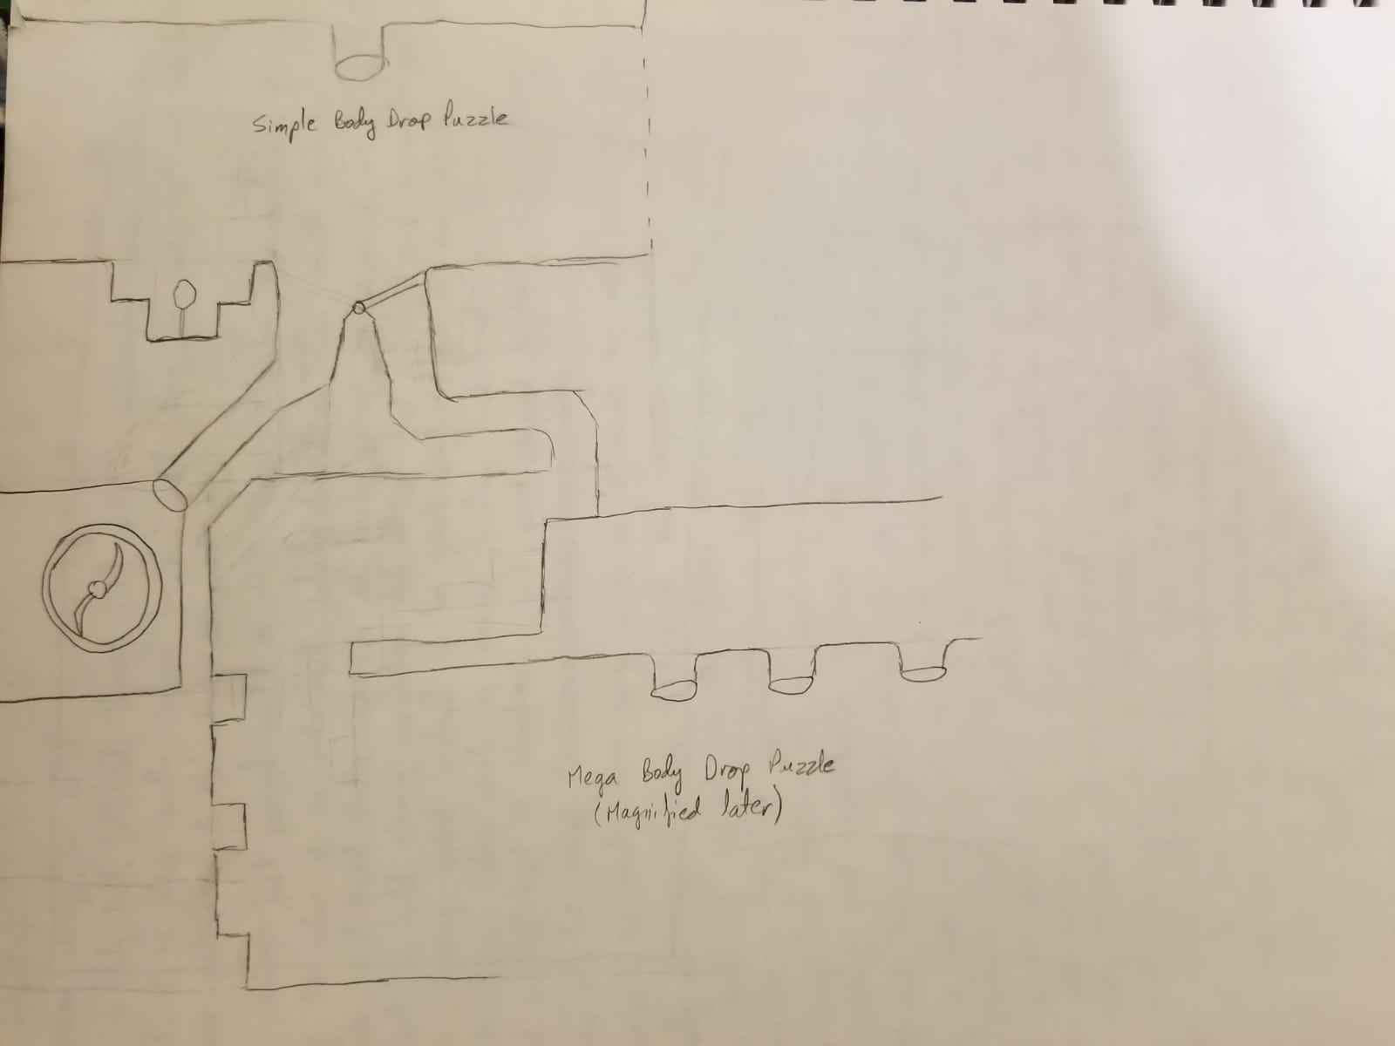

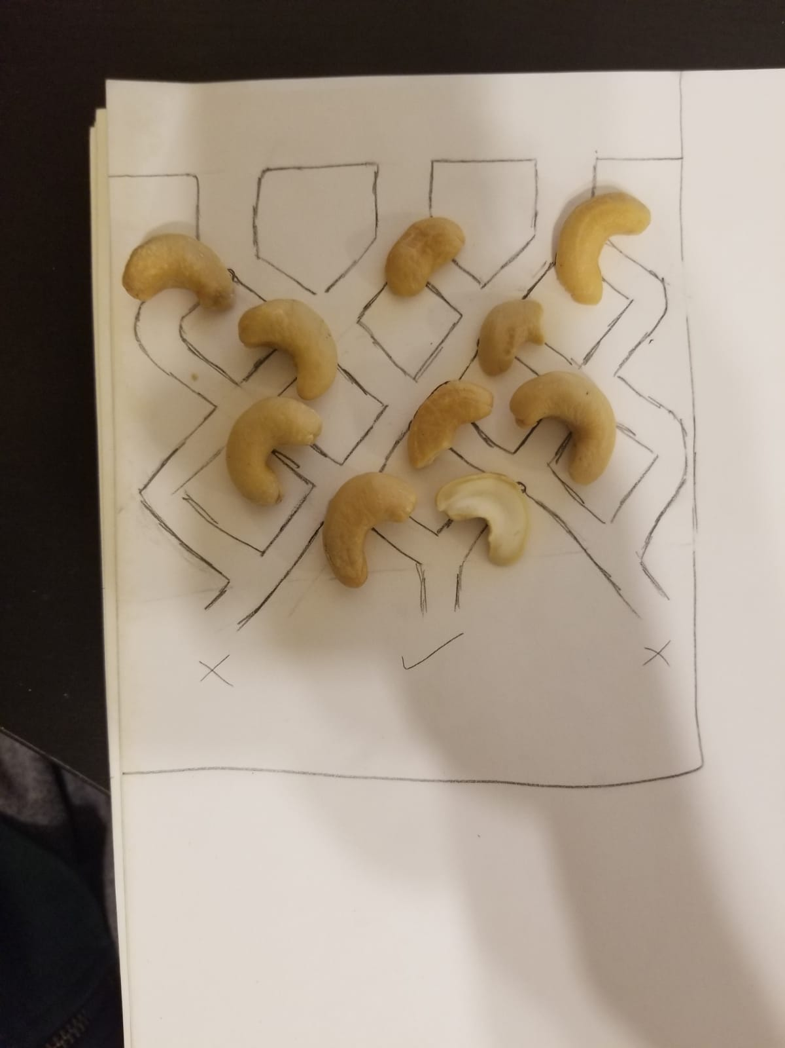

Here are some of my initial paper designs planning out a few of the major beats in the level. These helped me figure out what I wanted the level to be about, as well as to prove out conceptually whether or not the puzzles and challenges I was designing would end up being engaging and fun. These also allowed me to visualize the critical path for the challenges, and get an idea of how I wanted to place all the gameplay elements with respect to each other. As you can see, I had a nutty good time working on these plans!

**Walkthrough of the level:**

This is how the level looked almost towards the end of the project. There might be some updates that I made between taking this screenshot and my final submission, but the essence should be the same. I will cover each part in further detail below:

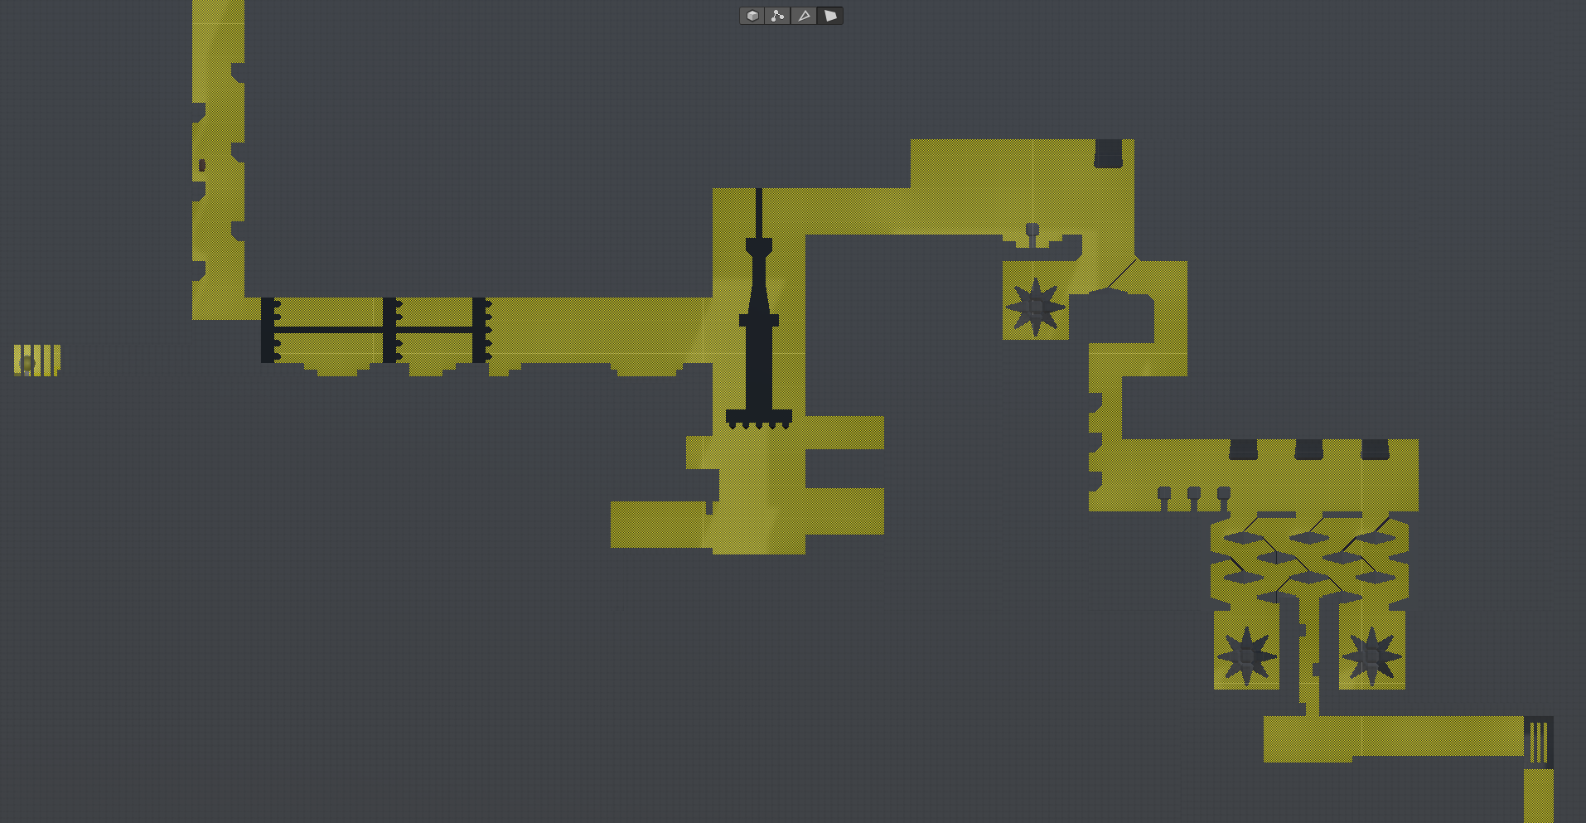

**Start**

**End**

**Secret**

**Sideways Challenge**

**Climb Up Challenge**

**Body Drop Tutorial**

**Mega Body Drop Puzzle**

Start area:

The level starts off with the player descending further into the facility after having escaped the Sonar puzzle section

Sideways challenge:



This section has the player encountering their first big machine in the area. Timing and quick fingers are key. Though the holes in the ground seem the obvious solution (and they are), they serve to lull the player into a false sense of security, both building up to the surprise fall at the end of this section as well as to get them in a complacent mood and potentially miss the secret area. If they notice the secret too late, they must backtrack and beat the challenge in reverse adding to its suspense and complexity.

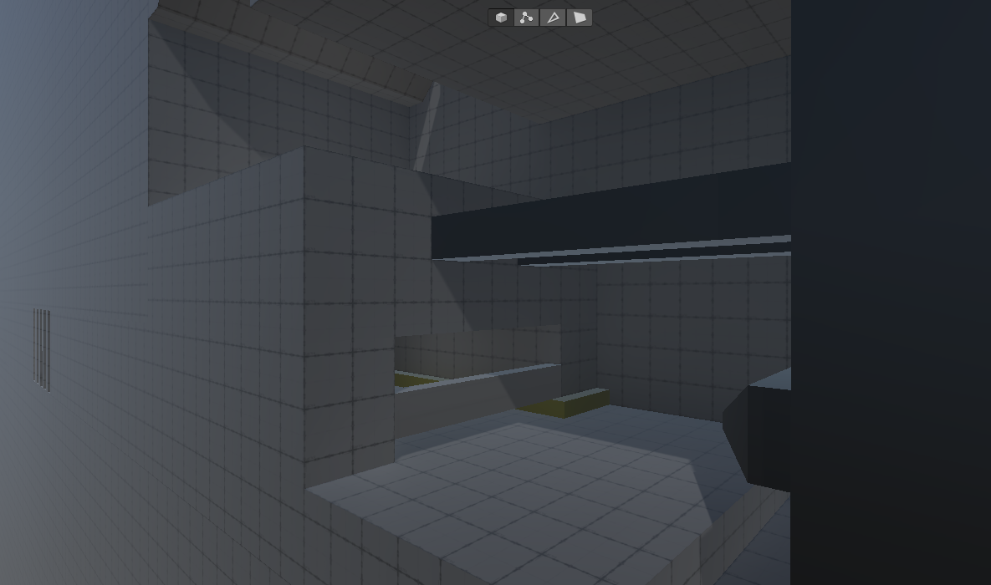

Secret area:

Players who are patient and aware will notice the yellow cable going behind a couple of planks to the west of the gigantic machine. They may choose to risk opening up and accessing this area as the machine continues to chug along. Once the path is open, players can journey further west to a secret area where they can destroy one of the secret orbs.

Climb up challenge:

Towards the end of the Sideways Challenge, as players near what seems like the end of the stretch, a trapdoor opens up under them having them take a deep dive into a puddle of water a couple of levels further down. The player must now climb back up using the machinery they have been trying to avoid, while journeying through the dark underbelly of the facility. Similar to the sideways puzzle, players need to time their moves with the pumping of the machinery taking leaps of faith and keeping their eyes open for any openings that are created.

Body drop tutorialization:

The latter half of the level focuses on the body drop puzzle, where the player must activate switches that result in bodies of Followers being dropped from pipes. As these bodies pass through gates, they flip them to the other side helping the player avoid hazards and make their way to safety. I divided this puzzle in two parts. This first tutorialization part would introduce the player to the mechanic and allow them to experiment with it in a relatively simple environment to see how things worked.



Mega body drop puzzle:

The second part of the Body drop puzzle would challenge the player to apply the knowledge they had learnt in the previous part to figure out a combination that would allow them safe passage. This puzzle has 3 switches linked to 3 pipes. Players must plan out and foresee the path each body would take as it goes through the maze and activate these optimally. They must also keep an eye out for a safe opening so that they can take the plunge themselves and come out unscathed on the other side.



Level end:

The level ends with the player reaching the elevator, that as the game continues sends the player plummeting into the water below.

**Time Management Summary:**

22/01/2021

* Began planning for Question 1
* Began and completed first pass of Question 2
* Set up unity project with basic character control and follow camera
* Set up the repository through GitHub

23/01/2021

* Completed first pass of Question 1
* Polished up Question 2
* Created a playable gym to prepare for whiteboxing and experimented with a few designs

24/01/2021

* Brainstormed major beats and flow of the level
* Worked on paper plan
* Started modularly whiteboxing some puzzles to prove out concepts
* Polished player controls

25/01/2021

* Whiteboxed major beats and puzzles
* Continued to test and polish player movement

26/01/2021

* Initial whitebox pass laid out with a bit of polish
* Cleaned up the start and end of levels as well as puzzle transitions
* Started work on events and adding gameplay elements

27/01/2021

* Polished up Question 1
* Began project report
* Hooked up more player interactions and gameplay elements
* Polished up the level geo a bit
* Refined and updated lighting
* Added checkpoint system and hints/controls guide
* Got level tested by others and took feedback

28/01/2021

* Completed project report
* Proofread all documentation and polished it up
* Polished up level, especially with regards to the feedback

**Feedback from others:**

After I had a build that I felt reflected the core gameplay well, and was clear enough, I got my brother and wife to test out my level. Their average run time was around 15 – 20 minutes. Below are some points of feedback I got from them:

* + The controls were unclear at the start
    - Taking this feedback I set the default state of the Player controls guide to be ON, so that players could have an idea of the tools that were available to them as soon as the game started, and could toggle these off after getting their bearings
  + The starting challenge (Sideways) felt a little unforgiving to be at the start of the level
    - I let this be as it was though since the level would not be intended to be played in isolation, and would be placed halfway through the game and so the player would have had enough time to come to terms with the controls
  + The last puzzle (Mega Body Drop) was good
    - I was happy to get this feedback, since this was the keystone that the entire level was building towards and it was good to see that this beat was engaging. To some extent a factor in this would also have been that this section was a welcome change of pace from the mechanics heavy earlier part of the level. The puzzle I felt was maybe a little too easy to solve, but it still seemed to create that moment of happiness I was looking for, as the player recognized that an opening had been created
  + Players really appreciated the checkpoints
    - The intention behind the checkpoints was to make the mechanically challenging earlier parts of the level a little less rage inducing, especially since I was throwing players right in the middle of the game since my level was intended to be one of the later ones. Thus I was glad that the checkpoints were serving their purpose
  + The secret was decently hidden
    - I was also glad to get this feedback, as it showed that the set up was doing its purpose

**Further Polish, Next Steps, and Known Issues:**

* + Jumping can sometimes feel a little unresponsive
    - Further polish of adding hang time and jump buffers should help here as well as some more polish to checking collisions with the ground and walls
  + Travelling on the machine in the Climb Up challenge can be smoothed out more
    - Going up makes it hard to jump off
    - Going down can be a little jittery
  + Physics collisions between the player and fast moving objects (like the machinery) can sometimes get the player to move through walls
  + Currently there is no fall damage in the level, even though some considerations have been placed to account for it
    - Adding fall damage would be a good next step to get a better sense of the gameplay
  + A big next step would be to further refine the level geo to evoke more of the essence of the environment, as well as to make rooms and areas stand out more

**Conclusions:**

Working on this Level Design test was a good opportunity for me to challenge myself to create an engaging level for an already solidly designed puzzle platformer. Putting myself in the shoes of the team behind INSIDE helped me understand the decisions and considerations they might have gone through, and was an interesting journey to undertake having also analyzed the game for this test. I also had a lot of fun challenging myself to hone my skills further, pick up better practices, and put more experience under my belt.

I hope you enjoyed reading through this document, and have fun playing through the level!

Cheers

Salim